Aviral Rajput

Athlone Institute of TECHNOLOGY

Weather Assignment REPORT

Contents

Introduction 1

Web Page 1

Ajax 3

DOM 3

CSS 4

REFELECTION 5

# **Introduction**

The aim of this assignment is to connect to openweathermaps.org API using an ajax request, to get the XML format weather forecast and display it on a web page to make it easier for the user to read. The user types in the name of the city they want and the weather information is then displayed on a table. The user will also be able to see the graph/chart of the weather for that day. I will be using JavaScript to implement my requests and displaying it on the web page using HTML and I will be styling the web page using CSS and Bootstrap. This application can be used by different people who want to know the weather forecast.

# **Web Page**

This is the home design of my web page and the first page the user will see when they run the “current.html”. the user will then need to type in the name city they want to check the weather forecast.

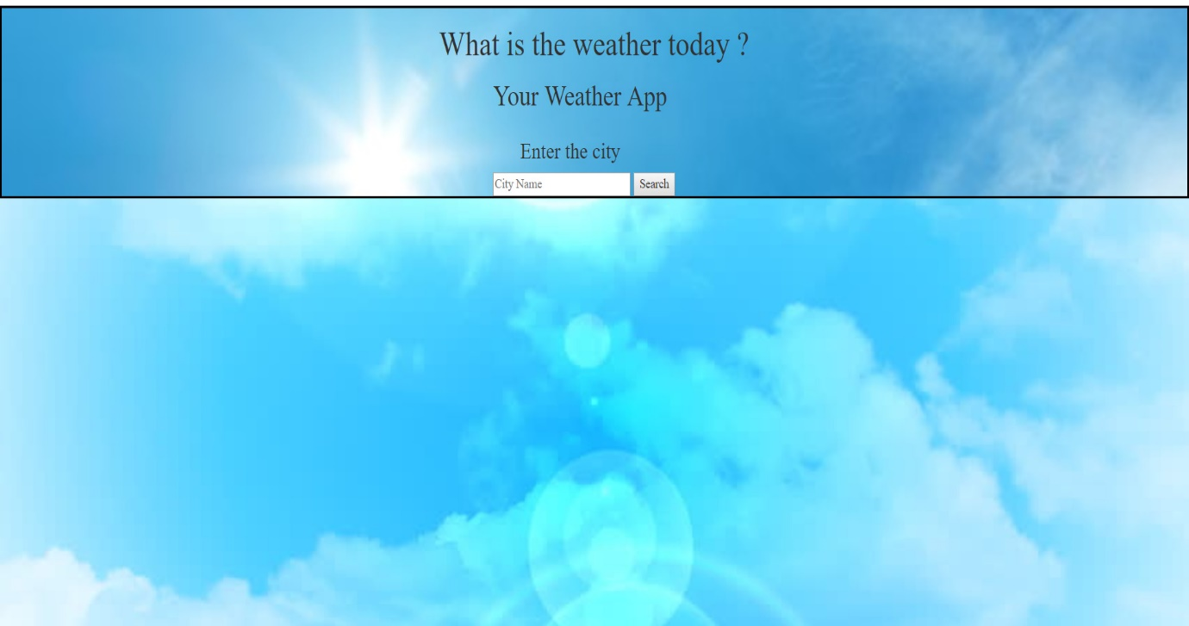

After the user enter the name of the city of the weather forecast they want to know, they will get a screen like this.

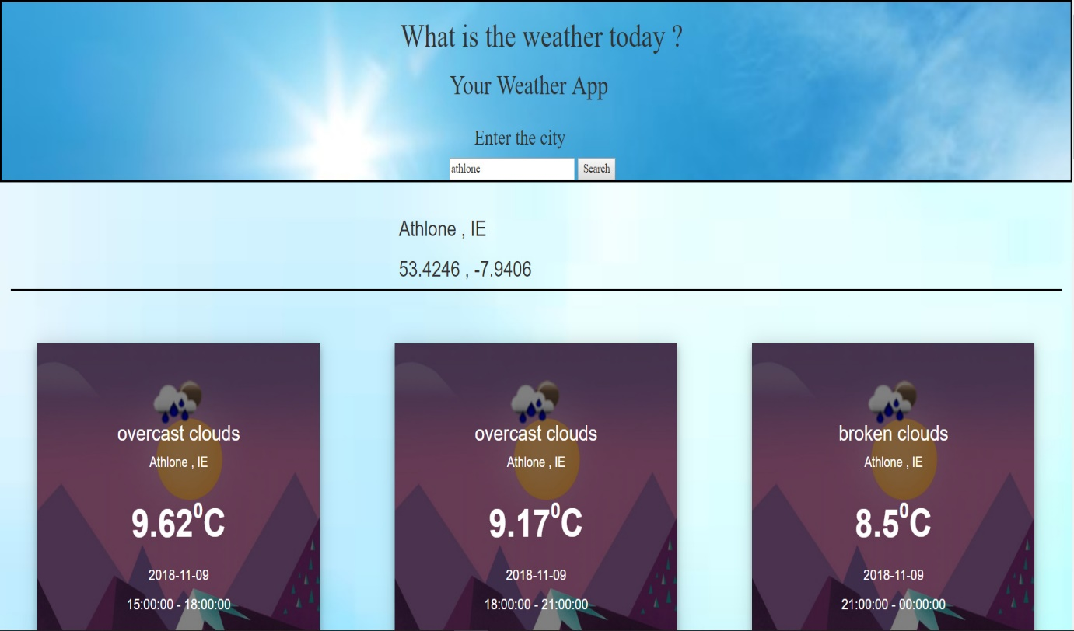

In the above picture is the forecast for Athlone. On the second div I have displayed the city name along with the country initials and the latitude and the longitude.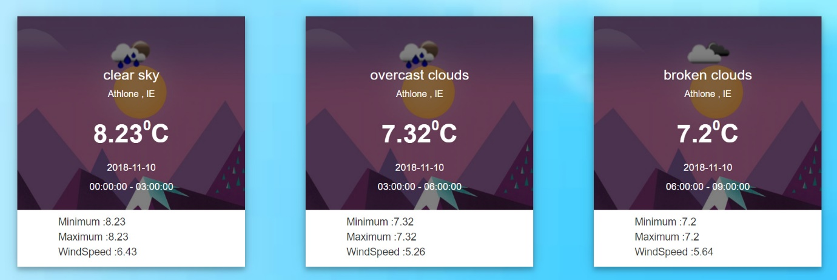

The weather with the time frames and the type of weather is shown in the weather cards that with the small icons give enough detail about how the weather is going to be within the provided time frame with the details of “Minimum Temperature”, “Maximum Temperature” and “WindSpeed” and with the image and description of weather i.e. Clear sky ,Broken Cloud, Over Clouds etc.

I have also added Charts from charts.js to interpret the data of forecast and to get the clear prediction for future which contains the wind speed and the temperature with the timestamp of three hours.

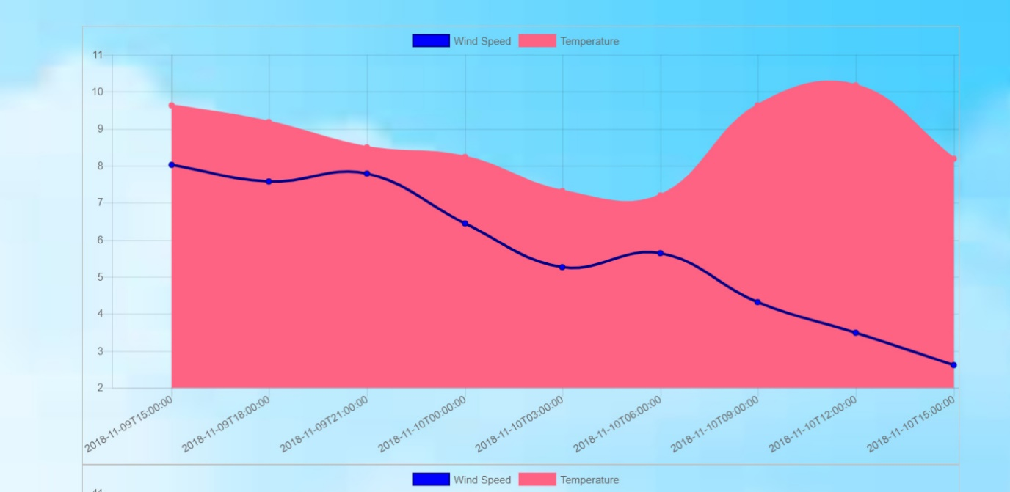

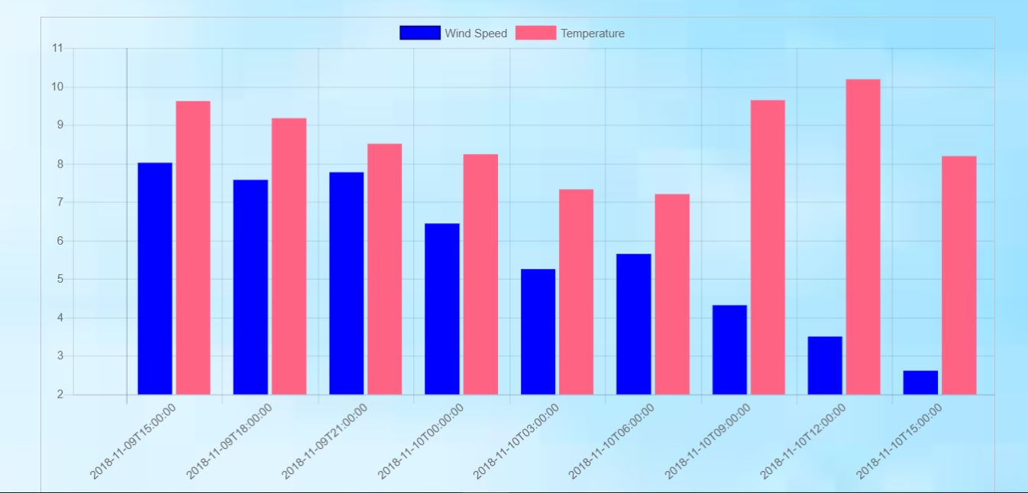

# **Ajax**

The function within my JavaScript code which initiates the AJAX call is name “getHTTPObject ()“. This function begins by initializing the HttpRequest object and setting it equal to a variable name “xhr”. This sets up the communication between the client and the server.

We then listen for a change in the HttpRequest object. If the HttpRequest object has changed then the AJAX needs to update to the new state of the object to which we pass the state to another method for formatting of the data.

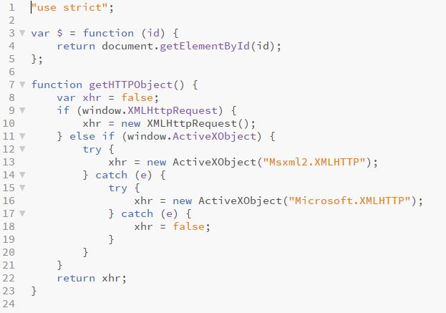

# **GetFile**

I used search() function to get the request from the openweathermap.com and provided it with the city name and appended it to the request with changing the unit to Celsius (metric) and provided with my value key to access the weather from my account.

This function gets the Ajax call via request variable to be successful which in turns call the ajax object.

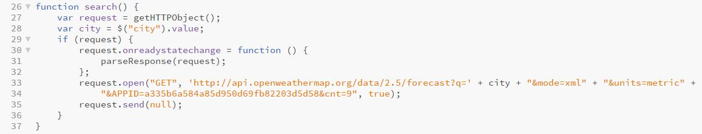

By appending the cnt-9 in the url we specify the time frame and the forecast we want from the list of forecast that is been parsed..

# **DOM**

I used the DOM model to display back the XML data that was requested in the AJAX call.

As you can see in my code the function show(data) basically parses the received XML data using the DOM concept.

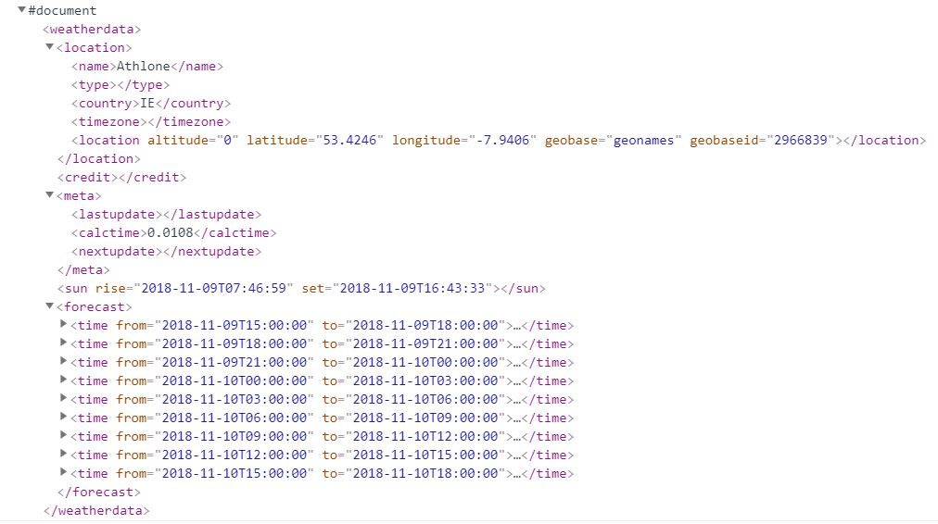

We can then use the data stored in the variable named “data” to navigate through the XML and use what we want. In the code shown below I have made arrays on information I needed and made Dom of the xml.

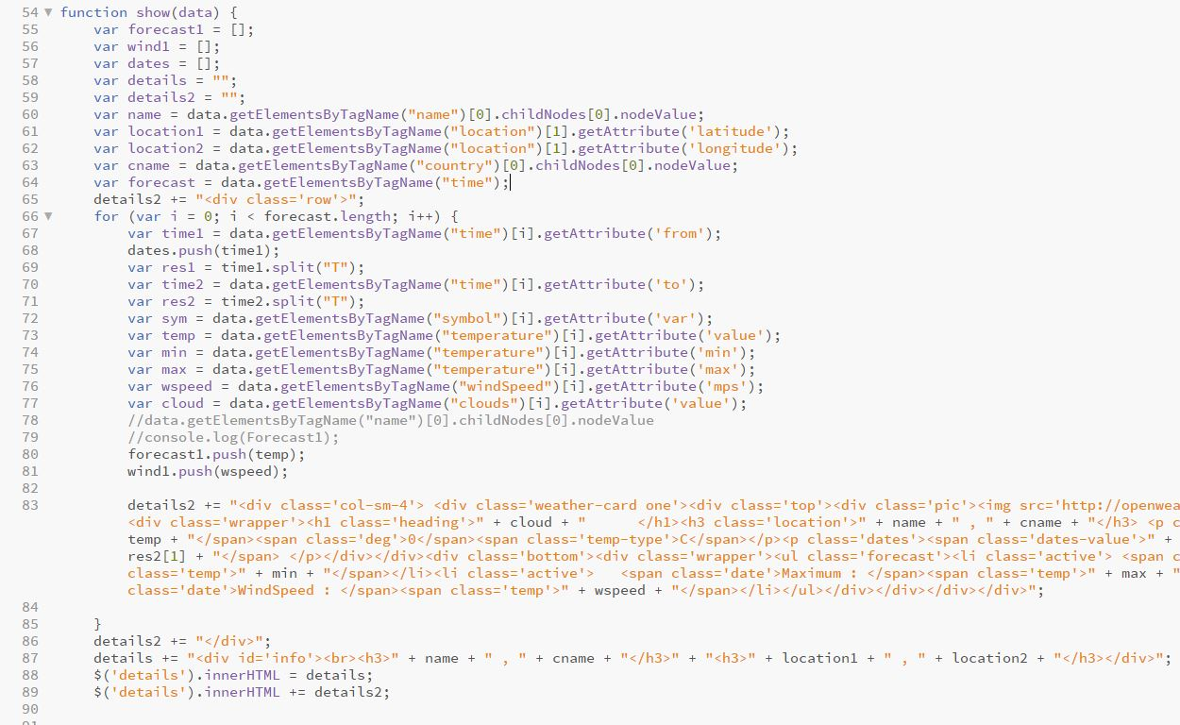

The above code explained:

* Firstly I made 3 arrays to store forecast, wind and dates to play around the chart as chart take values in array.
* Then I went inside the Dom hierarchy with tag names and attributes to fetch latitude, longitude, country and temperature. And stored in variables
* Navigating inside the forecast is little tedious as there are many forecasts inside the forecast tag so I appended the Count=9 in the url to take only 9 forecast and navigated isside the forecast.
* To take the time slot I separated the time by split function to get “To” and “From” time from the forecast.
* At the end I pushed the relevant data into relevant arrays and innerHTML to push into the html.
* With all the arrays in place I put the information into the weather card to display.

# **CSS**

I implemented just some basic CSS to display that I have learned from the labs. I implemented bootstrap and used canvas to plot charts.

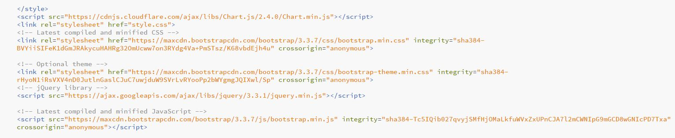

I created a weather card to display the fetched information into the card and used the .png images available with the openweathermaps.com to display the pictorial representation of the weather at current time.

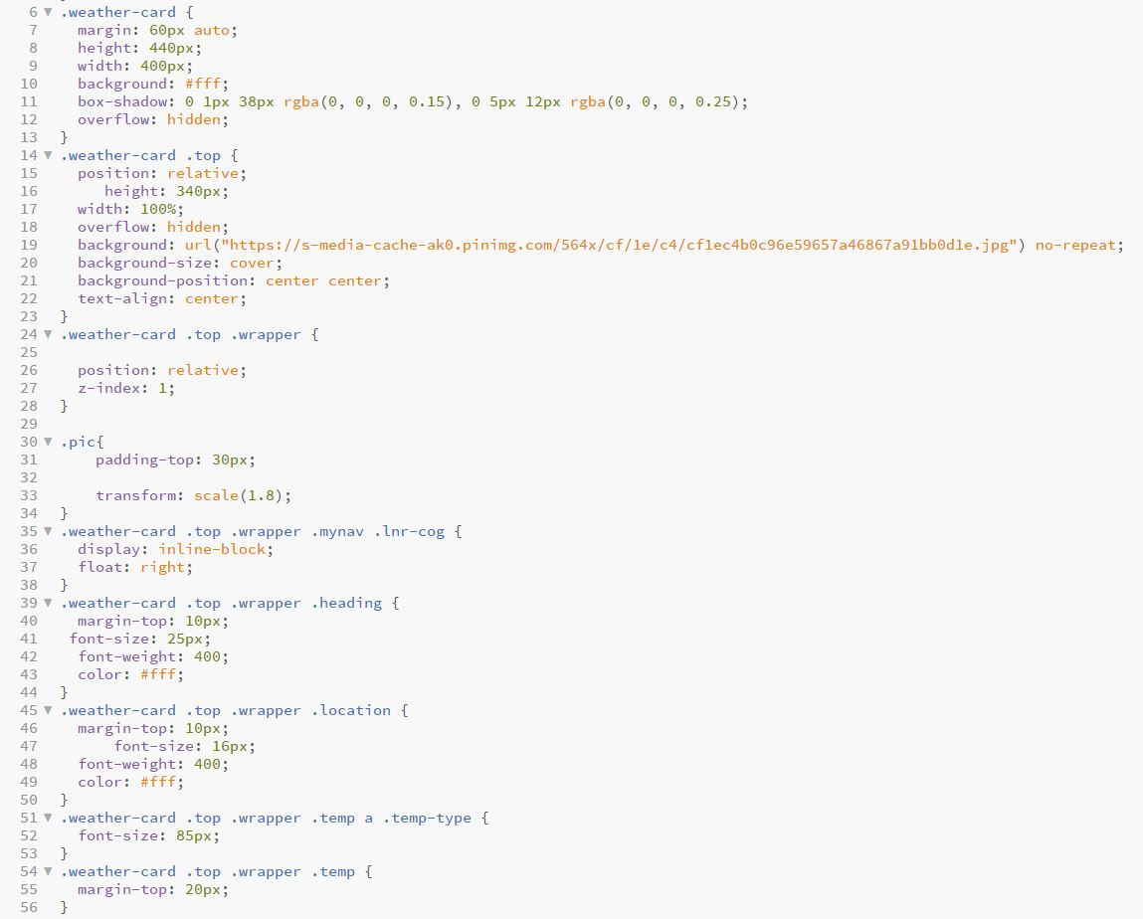

# **REFELECTION**

This assignment helped me in implementing my knowledge of what I have learned about Html, CSS and AJAX. Also with the help of this assignment I learned to use the API in real life scenario.

This assignment helped me to refresh my skills and I enjoyed this assignment and hope to build more assignments like this this will help me in future assignments and other projects.